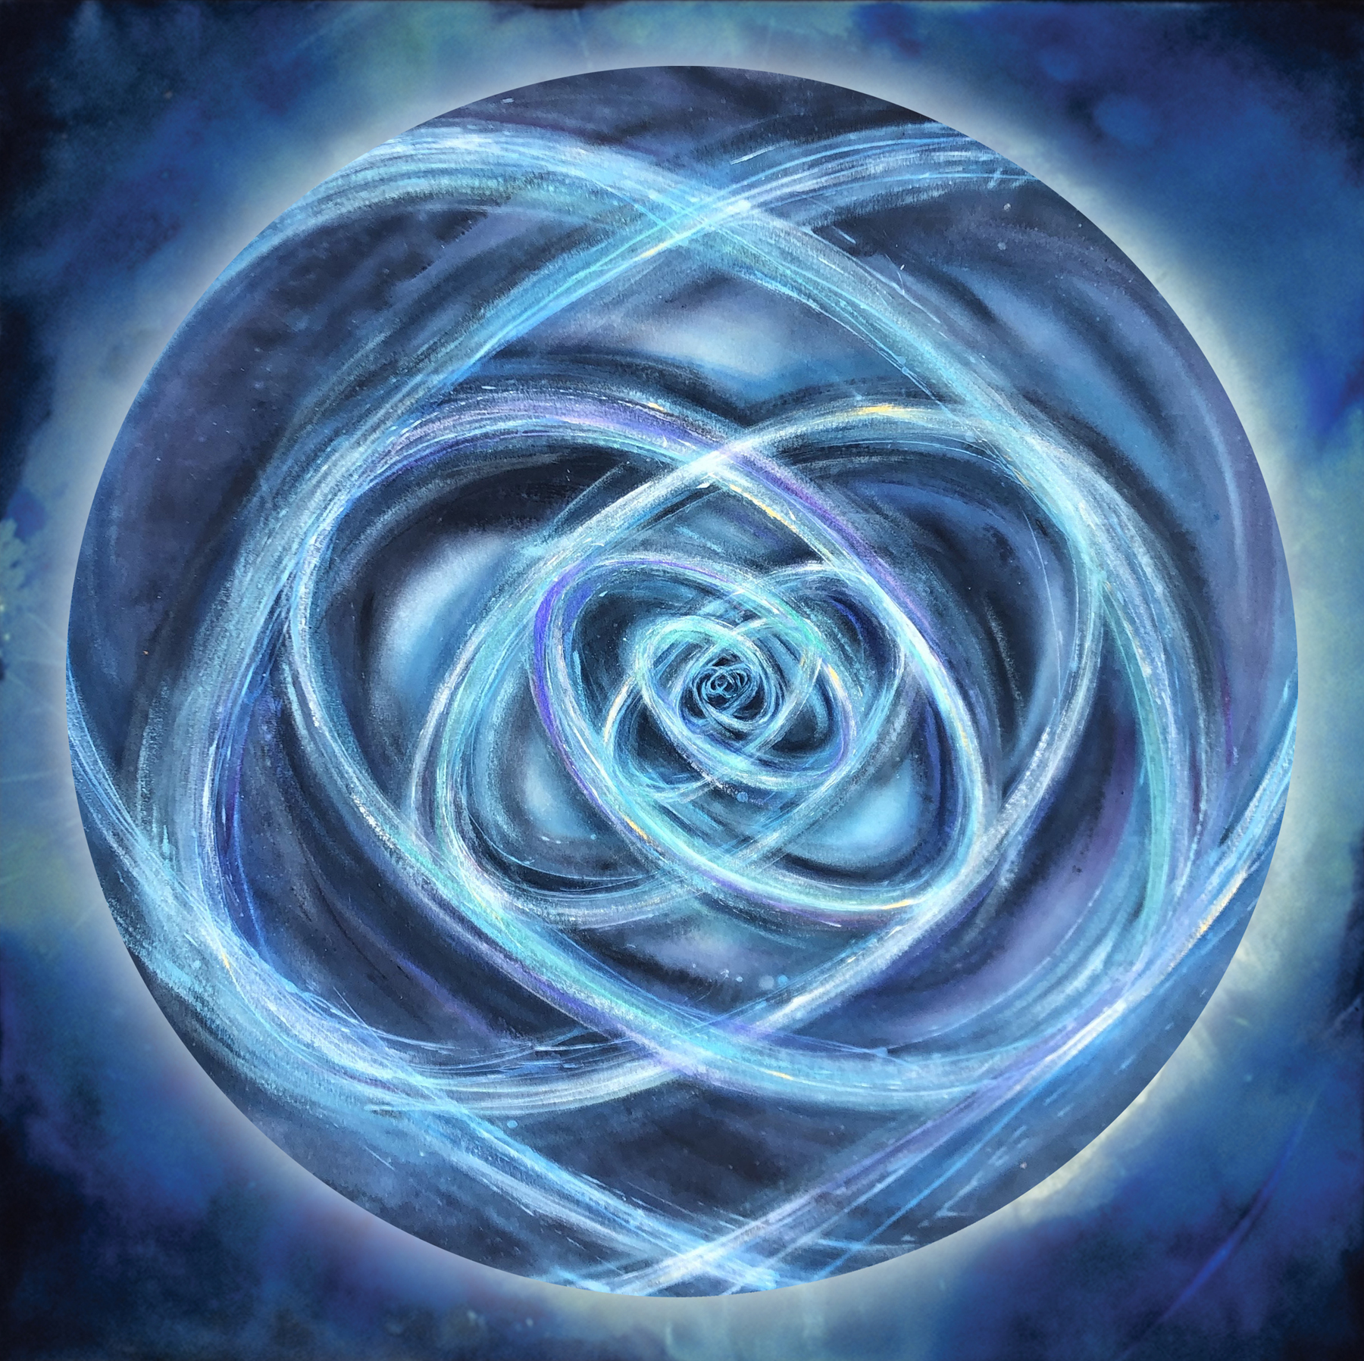
Meditating with The heart spiral doorway:

1. Print the heart spiral diagram on a piece of plain paper. Gather coloring supplies of your choice.
2. Enlarge the blue heart spiral image on your screen.
3. Set and setting: Seat yourself somewhere comfortable, with soft lighting, no distractions such as phone or other screens, with your door closed so you will not be interrupted. If on your own, play some soft ambient music in the background if you like.
Join us online for live-time meditation and drumming: Fri. March 20, 2020 7-8:30pm

Or meditate on your own: close your eyes and begin breathing long slow breaths, in and out, clearing your body and your mind. When you feel quiet inside, open your eyes to the center of the spiral. Soft focus works great.
Begin breathing into the center of the spiral: with your out-breath, breath into it, with your in-breath, draw the form into yourself, into your body, into your consciousness, bringing the love-light into every cell, organ, chakra and aspect of your body. Do this for as long as you like. You may want to try breathing imaginally through different body centers (heart, third eye, belly) or through body parts that are wanting some attention.

Write/sketch/doodle for a few minutes after the experience, and allow yourself to respond.

Color: now spend some time with the heart spiral diagram in any creative way: or draw your own version.

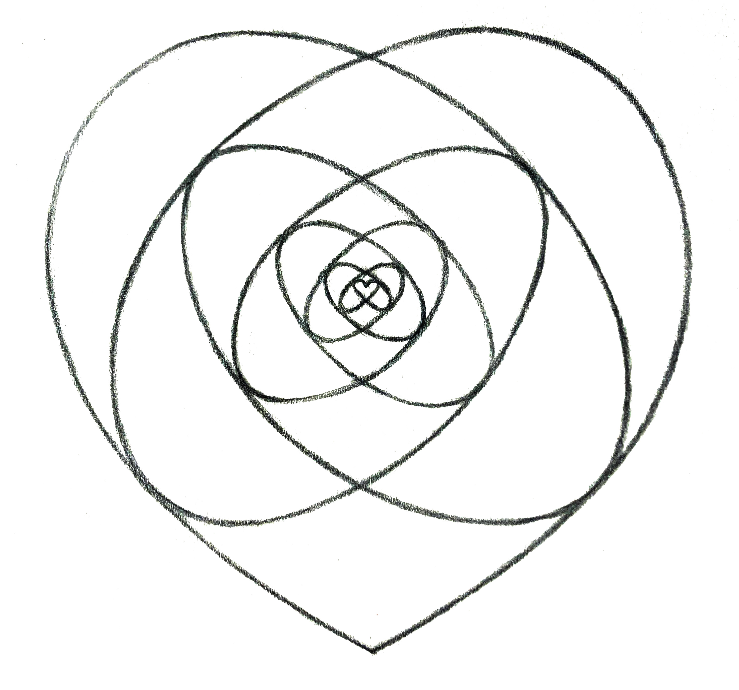
m.lindsey.art@gmail.com / www.artransforms.com / instagram: mlindseyart #heartspiraldoorway
all images painted/drawn by Margaret Lindsey. Please do not reproduce without permission. ©2020 Lindsey

